Roni Ruadap and Nakai

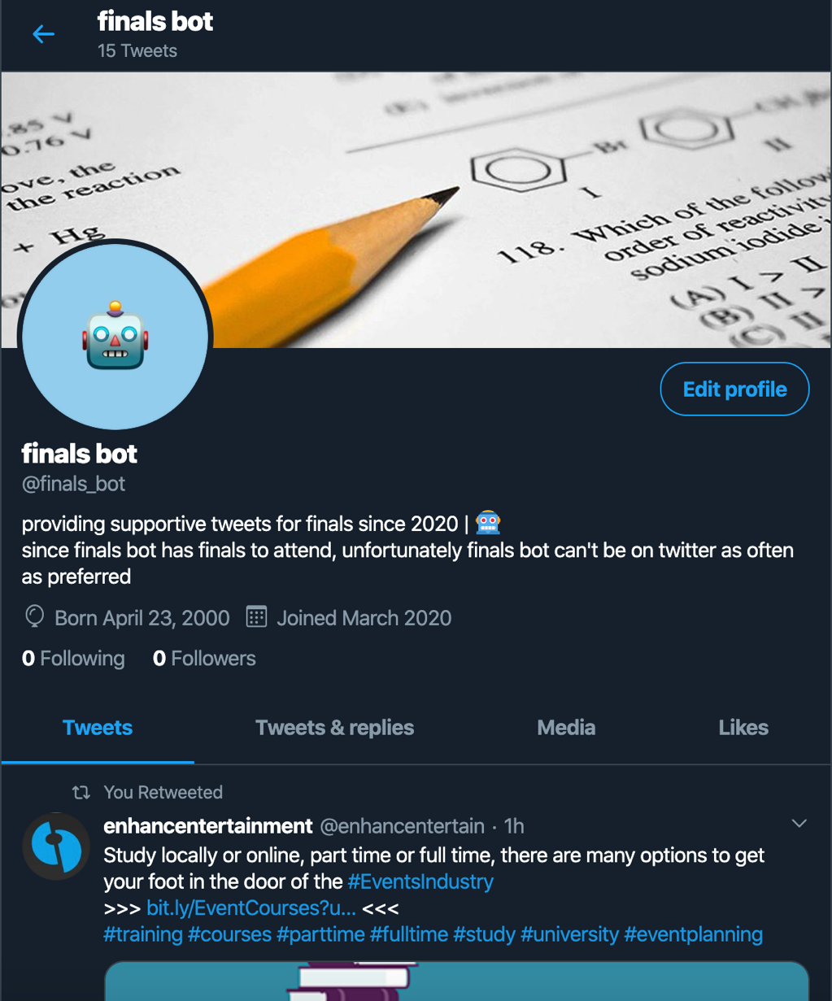

We made a twitter bot that provides support to students concerned about their final exams. The bot likes, retweets, post tweets, and replies to tweets mentioning @finals_bot to provide some moral support to twitter users. We did this because finals week can be mentally draining, and we thought it would be nice to have a social media account that tweets out supporting messages and advice. The bot engages with the school community on Twitter and it engages to posts with the hashtags "#finalsweek, #finalexams, #exams, #university, #tests, #college, #collegelife, #collegefinals, #studentlife, #universitylife. The community has not really responded but one so far has liked @finals_bot’s reply to their status update.

(delete later)

**Grading**

As indicated above, the basic bot must:

* take information from the Twitter feed
* modify or manipulate that information
* respond into the Twitterverse (e.g. post, retweet etc.)

If your bot performs these actions, your code is well commented, and your project statement is clear, you will receive a  B.  Bots that are performative, more sophisticated in the way that they take in and respond to input from Twitter, can receive a higher grade.